Belated: How to Setup and Use

# Instructions for Backend

Tested with the Ubuntu 12.04 (Long Term Support) release.

**Caution:** The spaces and hyphens used to display console commands in this document are nonbreaking. Therefore, you may encounter problems copying the commands verbatim into a terminal window.

## Installing MongoDB

Follow the instructions at <http://docs.mongodb.org/manual/installation/> for your specific OS.

For Ubuntu, this is:

1. Open Terminal
2. Run sudo apt‑key adv ‑‑keyserver hkp://keyserver.ubuntu.com:80 ‑recv 7F0CEB10
3. Run echo 'deb http://downloads‑distro.mongodb.org/repo/ubuntu‑upstart dist 10gen' | sudo tee /etc/apt/sources.list.d/mongodb.list
4. Run sudo apt‑get update
5. Run sudo apt‑get install mongodb‑10gen
6. You should now be able to start and stop the mongodb service using  
   sudo service mongodb start and sudo service mongodb stop.

## Installing the ‘Belated’ backend

1. Open Terminal.
2. Install git with sudo apt‑get install git.
3. Use the cdcommand to navigate to your home directory.
4. Run git clone https://github.com/patrickmeiring/belated.git
5. Use the cd belatedto navigate into the source directory you just cloned.
6. Install node with sudo apt‑get install nodejs.
7. Run node ‑‑version to determine what version of node.js you are running. You should be running v0.10.22 or later.
8. On Ubuntu 12.04, an old version (0.6.x) of Node is in the standard repository.   
   If you have an old version, you can use the instructions at <https://github.com/joyent/node/wiki/Installing-Node.js-via-package-manager> to update it. For 12.04, this means:

sudo apt‑get update  
sudo apt‑get install ‑y python‑software‑properties python g++ make  
sudo add‑apt-repository ‑y ppa:chris-lea/node.js  
sudo apt‑get update  
sudo apt‑get install nodejs

Then, Run node ‑‑version again to verify you have the correct version.

1. Run npm install

You should see a list similar to that below (N.B. items may be in a different order).

geo-distance-js@0.0.2 node_modules/geo-distance-js

dateformat@1.0.6-1.2.3 node_modules/dateformat

node-schedule@0.1.8 node_modules/node-schedule

nodemock@0.2.17 node_modules/nodemock

mockery@1.4.0 node_modules/mockery

icalendar@0.6.5 node_modules/icalendar

imap@0.7.11 node_modules/imap

└── utf7@1.0.0

mapquest@0.0.1 node_modules/mapquest

└── superagent@0.15.7 (methods@0.0.1, cookiejar@1.3.0, debug@0.7.4, qs@0.6.5, emitter-component@1.0.0, reduce-component@1.0.1, mime@1.2.5, formidable@1.0.14)

express@3.2.3 node_modules/express

├── methods@0.0.1

├── fresh@0.1.0

├── range-parser@0.0.4

├── cookie-signature@1.0.1

├── qs@0.6.4

├── debug@0.7.4

├── buffer-crc32@0.2.1

├── cookie@0.0.5

├── commander@0.6.1

├── mkdirp@0.3.4

├── send@0.1.0 (mime@1.2.6)

└── connect@2.7.9 (pause@0.0.1, bytes@0.2.0, formidable@1.0.13)

nodemailer@0.3.44 node_modules/nodemailer

├── optimist@0.6.0 (wordwrap@0.0.2, minimist@0.0.5)

├── simplesmtp@0.3.15 (xoauth2@0.1.8, rai@0.1.8)

└── mailcomposer@0.2.4 (mime@1.2.9, ent@0.1.0, mimelib@0.2.14)

mocha@1.9.0 node_modules/mocha

├── debug@0.7.4

├── growl@1.7.0

├── commander@0.6.1

├── diff@1.0.2

├── mkdirp@0.3.3

├── ms@0.3.0

└── jade@0.26.3 (mkdirp@0.3.0)

jade@0.31.1 node_modules/jade

├── character-parser@1.0.2

├── mkdirp@0.3.5

├── commander@1.1.1 (keypress@0.1.0)

├── with@1.0.4 (lexical-scope@0.0.12)

├── monocle@0.1.48 (readdirp@0.2.5)

└── transformers@2.0.1 (promise@2.0.0, css@1.0.8, uglify-js@2.2.5)

mongodb@1.3.18 node_modules/mongodb

├── kerberos@0.0.3

└── bson@0.2.2

mailparser@0.3.6 node_modules/mailparser

├── mime@1.2.11

├── mimelib@0.2.14 (addressparser@0.2.0)

├── encoding@0.1.7 (iconv-lite@0.2.11)

└── iconv@2.0.7

## Starting and Configuring the ‘Belated’ Backend

1. Ensure MongoDB is running. You can use sudo service mongodb start to start it if necessary.
2. To start the application, run sudo npm start.
3. If this is the first time running the application, you will be prompted to enter a number of configuration properties. The table below outlines the correct values -- be sure to enter them carefully!

|  |  |
| --- | --- |
| **Gmail account email** | calqut@gmail.com |
| **Gmail account password** | --Removed from GitHub version for security reasons-- |
| **Bing API Key** | --Removed from GitHub version for security reasons--  Or, get a new key at <http://www.bingmapsportal.com/> |
| **Mongo DB connection string** | mongodb://localhost:27017/ |
| **Live website domain** | The IP Address or domain of your computer or Amazon S3 instance, e.g. “54.252.45.18” |

1. If you make a mistake, you will need to shut down the server after configuration using Ctrl+C and edit the config.json file manually. Note: The characters in this file are escaped. For example, a back-slash in a json field is written as \\ and a double-quote as \".  
     
   On Ubuntu 12.04, you can do this with sudo gedit config.json. (N.B. sudo may be required if config.json file was created by the server and it ran with sudo.)

## Running Tests

This is an optional task, and not required to get the backend to work.

1. Run npm test.
2. No tests should fail. There may however, be a couple of “pending” tests – these are tests that have been intentionally disabled by the developer and do not indicate a problem.

# Instructions for Android App

## Installing the app on your device

1. The Belated Android App should be compatible with versions of Android from Ice Cream Sandwich (4.0, API level 14). However, Android 4.2 Jelly Bean (API level 17) is the only tested platform and is therefore recommended.
2. Obtain the MainActivity.apk file from <https://github.com/patrickmeiring/belated-client/blob/master/bin/MainActivity.apk>, or clone the repository and look in the “bin” directory.
3. Transfer the Android Package (APK) to your smartphone, for example using email.
4. Install the package, such as by opening the email attachment. You will need to give the app a number of permissions – including precise location, account details, internet access and control over the device’s power management.

## Configuring the app

1. Open the app from the Android launcher.

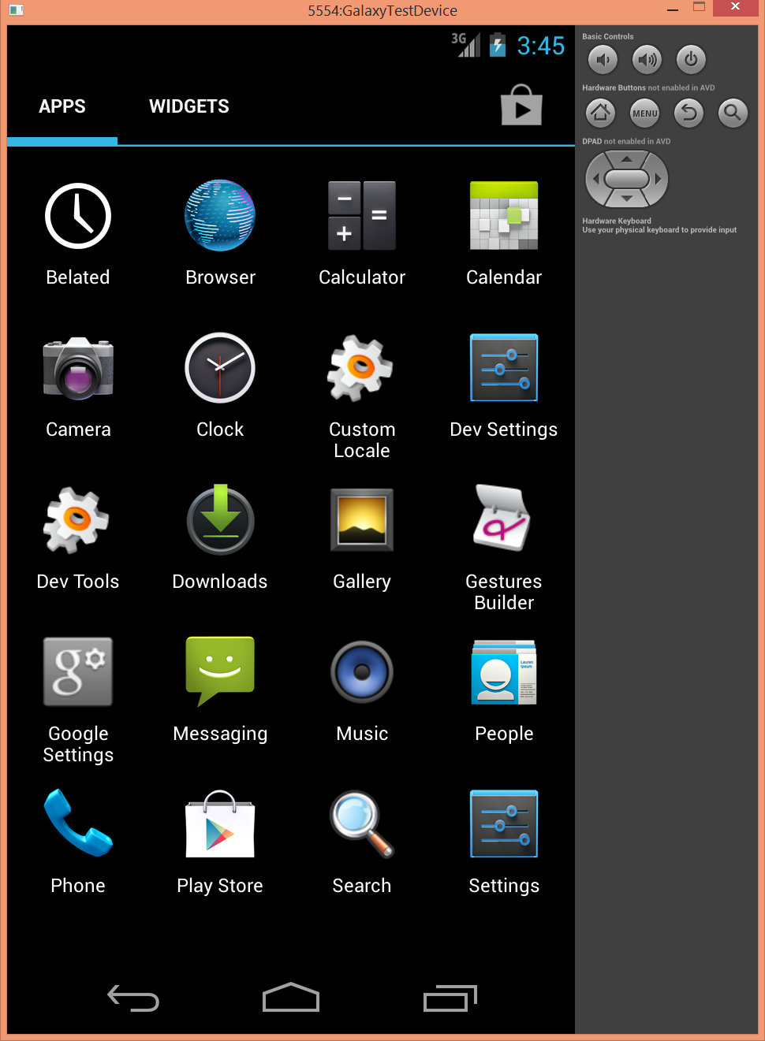

1. Tap the three vertical dots, then “Settings”.  
   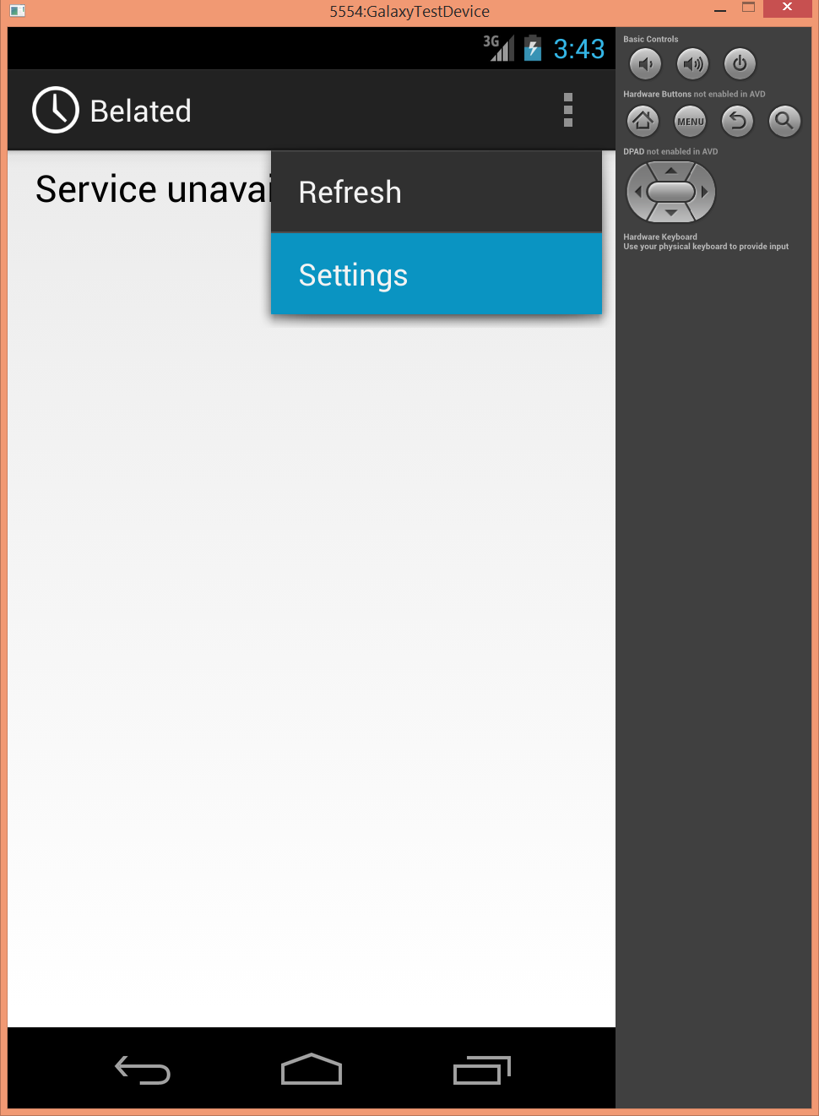

You should now see the Settings screen.

1. Configure the app as follows:

|  |  |
| --- | --- |
| **Belated Service** *This toggle enables or disables a background service on your phone, which sends your location to the backend. This is needed to for Belated to work properly, however you may turn it off at times to save battery and your privacy.* | ON |
| **Service IP** *The IP address or domain of the backend. If incorrect, you will see “Service unavailable” on the main screen.* | This should be the same as the configured “Live website domain” on the Backend (Refer to setting on pg. 3) |
| **Your email**  *The email address the app will download meetings and report location for. When performing a demo, this email should either be the organiser or attendee of a meeting request.* | E.g. “john.smith@qut.edu.au” |

1. Press back to save your settings. If you see “No upcoming meetings,” you have typed the correct service IP (better, you may see a meeting if you have already sent a meeting invite for configured email to the backend!)  
   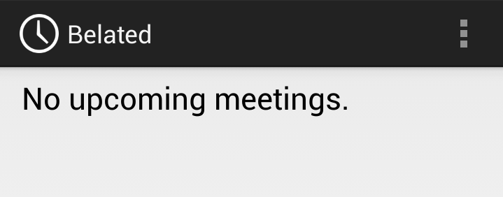

## Common Problems and Troubleshooting

**When I open the app, it only says “Service unavailable.”** Check that the Service IP in the app configuration is correct (see above). You should be able to see a web page on your smartphone when you navigate in the web browser to the Service IP you configured.

**When I open the app, it only says “No upcoming meetings.”** You need to send the backend a meeting invitation with either:

1. The exact email you specified in “Your email” as an attendee.
2. The exact email you specified in “Your email” as the sender and organiser of that meeting invite.

You can verify that these meetings have been received by looking at the backend console.

Then, tap on the three dots and hit “Refresh”.

**The buttons for Walking, Driving and Public Transport are greyed out.** 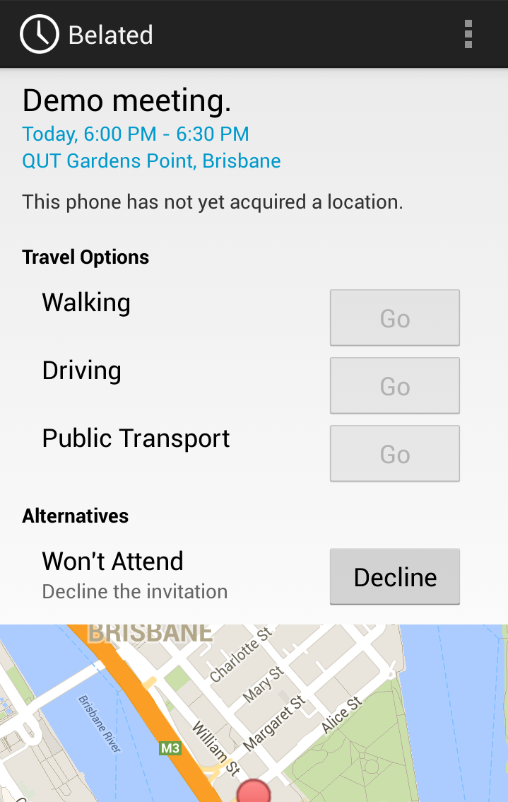

This is usually because the app has not acquired the phone’s location, and cannot yet invoke the Google Directions service.

Possible solutions:

1. Ensure you can see your location in the Phone’s maps app.
2. Ensure the Belated Service is switched to “On” in settings.
3. Verify your Phone’s GPS is enabled, or you have an active cellular SIM in your phone.
4. Reboot your phone.